Total Rentals & Season
----------------------------------------------------------------
&nbsp; Estimate Std. Error t value Pr(>|t|)
----------------- ---------- ------------ --------- ------------
**(Intercept)** 116.5 3.346 34.81 1.165e-256

**x** 29.18 1.223 23.85 9.182e-124
----------------------------------------------------------------
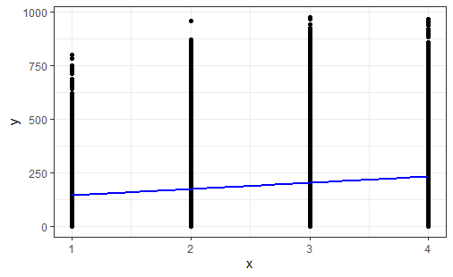
Total Rentals & Humidity

--------------------------------------------------------------
&nbsp; Estimate Std. Error t value Pr(>|t|)
----------------- ---------- ------------ --------- ----------
**(Intercept)** 379.9 4.43 85.76 0

**x** -303.6 6.75 -44.98 0
--------------------------------------------------------------
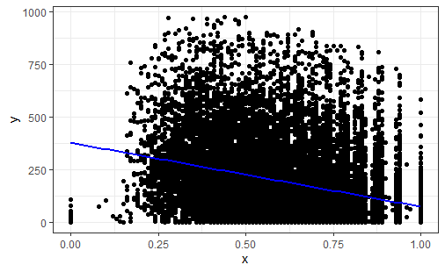

Total Rentals & Weather Situation
--------------------------------------------------------------
&nbsp; Estimate Std. Error t value Pr(>|t|)
----------------- ---------- ------------ --------- ----------
**(Intercept)** 247.1 3.328 74.24 0

**x** -40.41 2.13 -18.97 1.98e-79
--------------------------------------------------------------
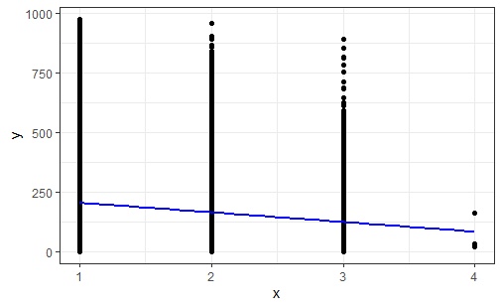

Total Rentals & Wind Speed

---------------------------------------------------------------
&nbsp; Estimate Std. Error t value Pr(>|t|)
----------------- ---------- ------------ --------- -----------
**(Intercept)** 163.2 2.531 64.46 0

**x** 2.063 0.1671 12.34 7.282e-35
---------------------------------------------------------------
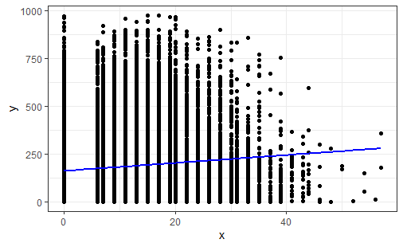

Total Rentals, Temp C & Working Day
----------------- ---------- ------------ --------- -----------
**(Intercept)** 40.38 4.176 9.671 4.57e-22

**x1** 9.644 0.2414 39.95 0

**x2** 37.59 5.184 7.251 4.3e-13

**x1:x2** -2.304 0.2953 -7.803 6.387e-15
---------------------------------------------------------------
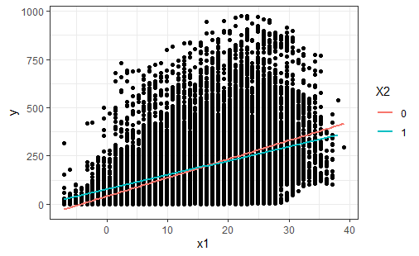

Total Rentals, Temp C & Season
---------------------------------------------------------------
&nbsp; Estimate Std. Error t value Pr(>|t|)
----------------- ---------- ------------ --------- -----------
**(Intercept)** 34.68 4.984 6.957 3.594e-12

**x1** 9.106 0.4328 21.04 4.548e-97

**x2** 15.04 2.077 7.24 4.68e-13

**x1:x2** -0.5459 0.1645 -3.319 0.0009059
---------------------------------------------------------------
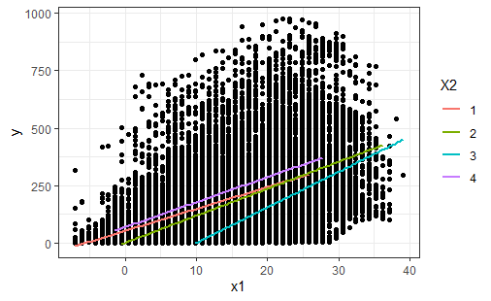
Total Rentals, Wind Speed & Weather Situation
----------------------------------------------------------------
&nbsp; Estimate Std. Error t value Pr(>|t|)
----------------- ---------- ------------ --------- ------------
**(Intercept)** 189.9 6.172 30.77 1.713e-202

**x1** 4.436 0.393 11.29 1.923e-29

**x2** -19.32 4.004 -4.826 1.405e-06

**x1:x2** -1.608 0.2506 -6.418 1.415e-10
----------------------------------------------------------------
